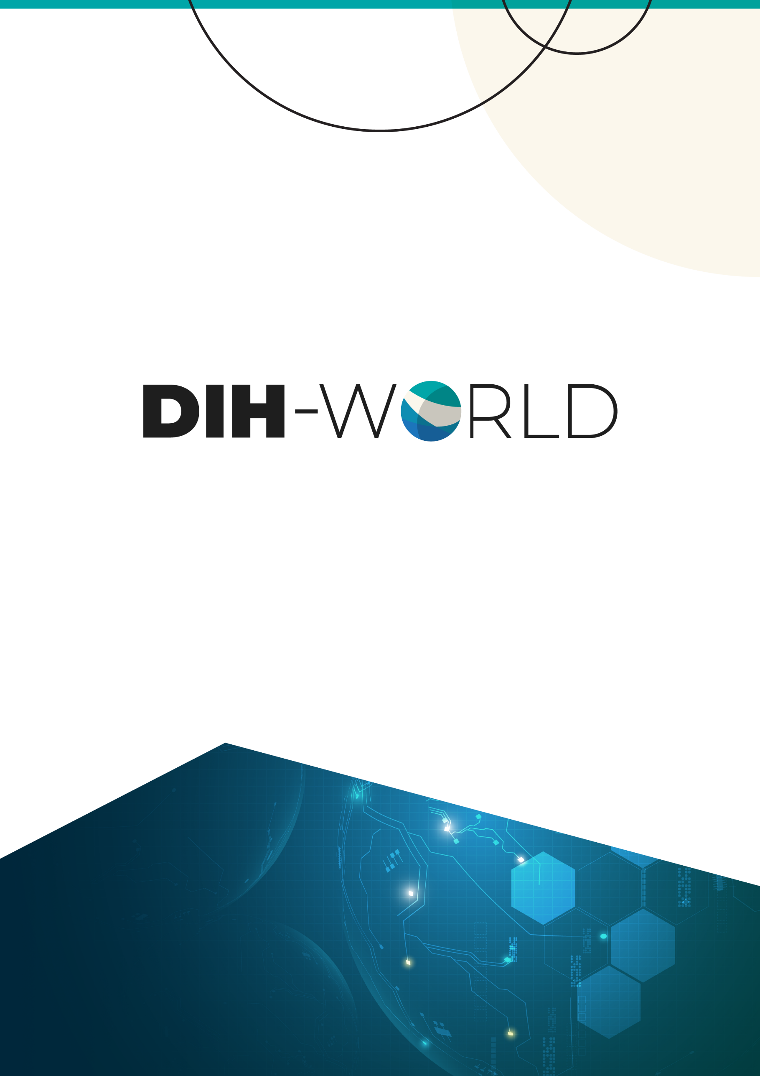

Proposal template for

Innovative experiment

Title OF THE EXPERIMENT

INSTRUCTIONS
(Please remove this instruction page before submitting as well as the explanation in italic in the following pages.)
This template is to be used for all proposals to be submitted to the first DIH-World open call.
The structure of this template must be followed when preparing your proposal. It has been designed to ensure that the important aspects of your planned work are presented in a way that will enable the evaluators to make an effective assessment against the evaluation criteria.
Please be aware that proposals will be evaluated as they were submitted, rather than on their potential if certain changes were to be made. This means that only proposals that successfully address all the required aspects will have a chance of being funded. There will be no possibility for significant changes to content, budget and consortium composition during grant preparation.
Page limit: There is a page limit of 10 pages starting from section 1. Experiment Overview. All tables, figures, references and any other element pertaining to these sections must be included as an integral part of these sections and are thus counted against this page limit.
If you submit a proposal longer than the specified limit (10 pages), excess pages (in over-long proposals) will be automatically disregarded, and will not be taken into consideration by the evaluators. The proposal is a self-contained document. Evaluators will be instructed to ignore hyperlinks to information that is specifically designed to expand the proposal, thus circumventing the page limit.
Formatting conditions
The following formatting conditions apply:
- The reference font for the body text of H2020 proposals is Arial (Windows and Apple platforms) or DejaVu Sans (Linux distributions).
- The use of a different font for the body text is not advised and is subject to the cumulative conditions that the font is legible and that its use does not significantly shorten the representation of the proposal in number of pages compared to using the reference font (for example with a view to bypass the page limit).
- The minimum font size allowed is 11 points. Standard character spacing and a minimum of single line spacing is to be used.
Text elements other than the body text, such as headers, foot/end notes, captions, formula's, may deviate, but must be legible.
The page size is A4, and all margins (top, bottom, left, right) should be at least 15 mm (not including any footers or headers).

CONTENTS
1 TECHNICAL EXCELLENCE 4
1.1 Objectives of the experiment 4
1.2 Experiment overview 4
1.3 Scientific and Technological Excellence 4
2 IMPACT 5
2.1 Expected impact on the SME 5
2.2 Expected impact on the DIH. 5
2.3 Dissemination and exploitation plan 5
2.4 Cross-border activities 5
3 IMPLEMENTATION 6
3.1 Work Plan 6
3.1.1 Work package 6
3.2 Budget of the experiment 6
3.3 Consortium presentation. 7

TECHNICAL EXCELLENCE
  - Indicative number of pages: 3 pages

Objectives of the experiment
- Describe the objectives of the experiment in a SMART manner: Specific, Measurable, Achievable, Realistic, and Timely.
- Indicate how the experiment objectives are aligned with the DIH-World open call objectives.

Experiment overview
- Describe the main concept, including sector, technology (I4MS technologies) and geographical location.

Scientific and Technological Excellence
- Describe the innovative nature of the experiment.
- Identify the novel concepts and approaches as well as their added value to the state-of-the-art.
- Explain the implementation and adequate usage of the technologies involved.
- Describe the challenges that the experiment intends to address and indicate how it will improve the current processes, products or services of the SME. Specify starting and ending TRL levels.

IMPACT
  - Indicative number of pages: 3 pages

Expected impact on the SME
- Explain the contribution of the experiment to increase the digitalisation level of the SME. Technological, economic and commercial impacts foreseen. Include KPIs.

Expected impact on the DIH.
- Explain the contribution of the experiment to the goals of the DIH.

Dissemination and exploitation plan
- Present the dissemination activity plan.
- Present an exploitation model for the application experiment including ownership of results (IPR), if applicable.

Cross-border activities
- Describe the cross-border activities of the experiment, if any.

IMPLEMENTATION
  - Indicative number of pages: 4 pages, including tables

Work Plan
- Provide the work plan and tasks including a Gantt diagram and description of work package.

Work package
- Describe all the activities to be implemented in the experiment using the following table for each work package:
Work Package: Task name
Task(s) description: Describe the tasks to be carried out
Role: Role of each partner
Milestone(s): Milestone short description (Month XX)
Deliverable(s): Deliverable short description, related to the milestones (Month XX)

Budget of the experiment
- Provide a summarised budged for the experiment using the following table. Provide justification in case you include subcontracting costs.
Table 1. Overall proposal budget.
 | Partner 1 | Partner 2 | Total
1. Direct Personnel costs
2. Direct costs of subcontracting
3. Indirect costs (25% of row 1)
4. Total costs (sum of rows 1, 2 and 3)
5. Requested funding

Consortium presentation.
- Describe the SME and DIH organisations, the teams, infrastructures and experience. Demonstrate that the partners possess the required competence to implement the project.
- Explain the adequateness of the consortium members.
- Detail the role of each partner in the experiment.
- Describe the DIH, particularly the service provided to implement the experiment.
- For the DIHs, indicate the expectations in being part of the DIH-World community.

‘Direct personnel costs’ are those related to personnel working for the beneficiary and directly linked to the experiment implementation.
‘Direct cost of subcontracting’ if necessary to implement the experiment, the beneficiaries may subcontract certain activities. The amount devoted to subcontracting activities shall be in line with the needs of the experiments.
‘Indirect costs’ are costs that are not directly linked to the action implementation and therefore cannot be attributed directly to it. Indirect costs are declared on the basis of the flat-rate of 25% of the direct personnel costs.
Funding rate is 70% (100% for non-profit organisations).

